

ST JOHN’S CATHOLIC CHURCH - NORTH RIDING
Parish Priest: Fr Bafana Ndlovu OMI
WhatsApp(text only): 067 402 5566
Parish Office: 010 222 0631
E-mail: northriding.stjohn@catholicjhb.org.za; ppc@st-johns.org.za
The parish office hours - Monday to Friday, 8.30am to 3pm
Mass times: Saturday 5.00pm;
Sunday 7.30am and 9.30am and 5.00pm.
Mondays and Thursdays 6.15am;
Tuesdays, Wednesdays & Fridays 9.00am.
Weekday Public Holidays: 8.00am
Website: http://www.st-johns.org.za

Nineteent SUNDAY Cycle A 8/9 AUGUST 2026

FIRST READING : 1 Kings 19:9.11-13

RESPONSORIAL PSALM : Psalm 85

R: Let us see, O Lord, your mercy,

and grant us your salvation.

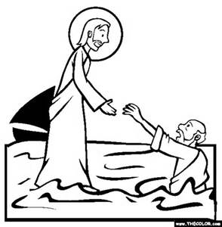
I will hear what the Lord God speaks;
He speaks of peace for his people and his faithful.
His salvation is near for those who fear him,
and his glory will dwell in our land.

Merciful love and faithfulness have met;
justice and peace have kissed.
Faithfulness shall spring from the earth,
and justice look down from heaven.

Also the Lord will bestow his bounty,
and our earth shall yield its increase.
Justice will march before him,
and guide his steps on the way.

SECOND READING :Romans 9:1-5

GOSPEL ACCLAMATION
Alleluia, Alleluia!
I wait for the Lord, in his word I hope..
Alleluia!

GOSPEL : Matthew 14:13-21

“Bid me come to you on the water.”

Community News

DAY OFF: Fr Bafana OMI takes his one day off a week on a Monday. Please respect this important day of rest for our parish priest.

FUNERAL ARRANGEMENTS: Contact the office to make arrangements.
Please note we don’t hold funerals on a Saturday or Sunday.

COUNSELLING: Please leave a message on 071 138 8401 to make arrangements for counselling.

PRAYER CHAIN: Phone Connie on 010 220 5109 or 083 694 8319 for prayer support.

ANOINTING OF THE SICK: Please contact the parish office or ask an immediate family member to do so on your behalf so we can make arrangements for Father to see you.

BIBLE SHARING: You are invited to join on Monday evenings at 7.00pm on Zoom. Contact Evelyn on edevelyndeiner25@gmail.com

LECTIO DIVINA: Join us on Thursday evenings at 8.00pm on Zoom. Contact Gordon at gordon.brewer@liblink.co.za

JUSTICE & PEACE: We invite you to a meeting every Tuesday from 7.00pm. To get a link to the meeting please contact us on email - stjohnsjusticepeace@gmail.com.

CHARISMATIC PRAYER GROUP: All are welcome to join on a Thursday from 6.00pm - 8.00pm.

SOCIETY OF ST VINCENT DE PAUL- SSVP. New members are needed and we would love you to join this ministry. Please contact Maqueen Ntladi on 083 236 5719 or Michael Wise on 082 561 6980

Sacraments and Preparation

BAPTISM: Parents are required to attend a course before the baptism of their child. Contact the office on 010 222 0631 to make

an appointment to meet with Father to discuss baptism and attend preparation classes.

CONFESSIONS: Confessions are on Saturdays from 3.45pm till 4.45pm, or by appointment.

MARRIAGE: Contact Fr Bafana three to six months before the event. Couples are required to attend a pre-marriage course of instruction or an Engaged Encounter weekend.

CATECHISM (Primary School)
& CONFIRMATION (High school)
Contact the office.
***REGISTRATION FOR 2027 WILL
OPEN IN OCTOBER ***

*Catechism Classes to be attended
from Grade 1 to Grade 7
in order to receive continued formation
and to ensure all Sacraments are
received in good time.
*Confirmation classes must be attended
From Grade 8 and is a 3.5 year program.

PRAYING THE ROSARY: The Rosary is prayed as a community every Monday and Thursday after the 6.15am Mass and on Tuesday, Wednesday and Friday at 8.30am before the 9.00am Mass. The Rosary is also prayed in front of the grotto of Our Lady on the FIRST SATURDAY of each month at 9.00am.

ADULT RCIA/CONVERT CLASSES / FAITH ENRICHMENT CLASSES:
If you are over 18 and interested in deepening your faith or becoming a Catholic, classes begin each year after Easter. Please phone the parish office for more details on the course.

St John’s Mission Statement
A community that encounters Christ through the worship and spiritual guidance
of God by loving and supporting our fellow brothers and sisters.


Community Notices

REMINDER: The gate will be closed at the start of Mass.
Please arrive at least 15 minutes before Mass begins.

PUBLIC HOLIDAY: Mass on Monday the 10th of August will be at 8am due to the public holiday.

PARISH REGISTRATION AND RE-REGISTRATION:
"Is your parish registration up to date? The Church Administration is currently updating our database so we can better understand and serve our community. A precise registry helps us build a more welcoming, inclusive parish where everyone feels a true
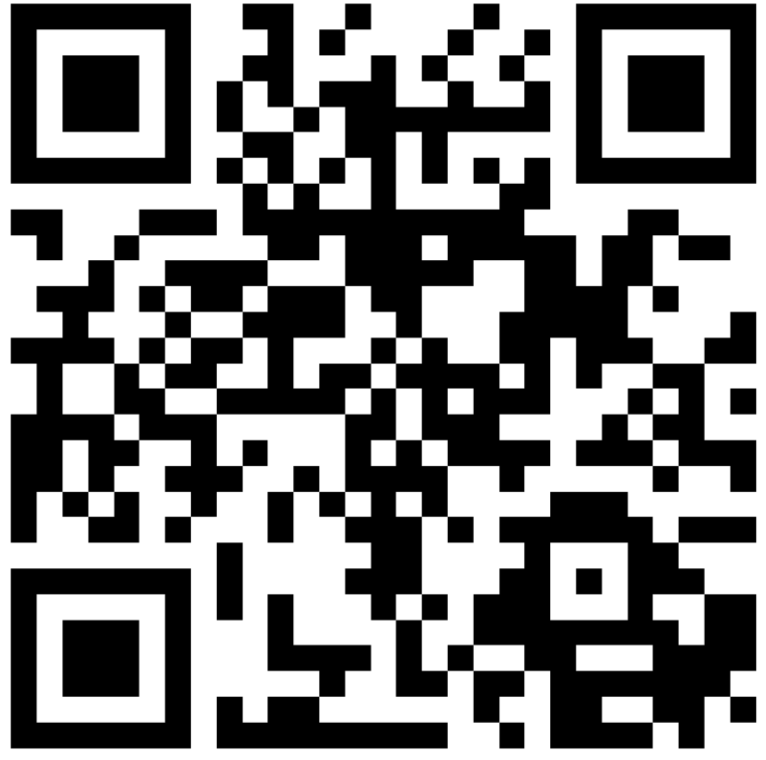
sense of belonging. Please may all parishioners take a moment to
Register or re-register or update your family’s details via this QR Code
or on our website.

Privacy Note: Your information is held in the strictest confidence.
It is used solely for parish administration and will never be shared
externally without your prior permission."

SENIORS MONTHLY MASS
The Monthly Seniors Mass will take place on Wednesday, 12 August 2026, at 10 a.m. All Senior Citizens of the Parish are welcome and are invited to attend. Refreshments will be served in the Parish Hall after Mass.

VISITING PRIESTS: Any visiting priests from outside the diocese have to present
a valid document (called a Celebret and pronounced Cheh-LEH-breht) from their diocese at least a week before the visit. They will NOT be allowed to concelebrate at Mass nor celebrate any Sacraments prior consent.

HEALTH AND SAFETY: We are updating our Health and Safety protocols, if there are any parishioners who are more knowledgeable in this, please consult the parish office to offer your assistance.

GRIEFSHARE: A 13 week program to assist you in dealing with the loss of a loved
one commences on Saturday 15 August at 10 am in classroom no 7. The cost of the workbook is R300. For more information, please leave a message for Arianna on 071 138 8401.
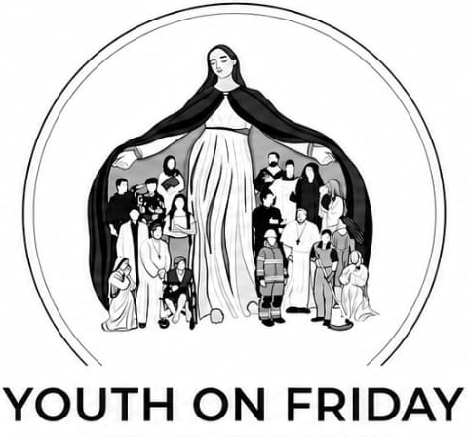
YOUTH ON FRIDAY: WALKING THE FAITH –Living the Catholic Faith in Real Life. For High Schoolers and Young Adults
Every 1st and 3rd Friday 6pm – 9pm in the Parish Hall
For More information or to join contact Jason – 060 684 0449
ST ANNE’S SODALITY INVITES THE COMMUNITY TO JOIN US FOR OUR ANNUAL FUNDRAISING ACTIVITY: FUN WALK AND PICNIC
Golden Harvest Park Saturday, 10 October 2026, 9am Start
Theme: Walking together as pilgrims of hope.
Participation fee: • Adults - R220 with T-shirt
R100 for those who will wear last years shirt.
Children under 12 - R180 with a T-shirt



Mass Intentions for the week.

Saturday 8 August 5.00pm Blaise Rutherfurd R.I.P
Felisbella Camacho R.I.P
Jim & Sadie Maguire R.I.P
Healing for Goretti Vieira
For the Holy Souls & for the Pereira Family
Special Intention for Christine Azel

Sunday 9 August 7.30am Antonio da Serra R.I.P
Alex, Alexandra & Albertina De Gouveia R.I.P
Don Vasconcellos R.I.P
Healing for Christine Azel
Intentions of Wayne and Charmaine Towell & Family
Special Intention Thabile Mbhele

9.30am Lindiwe Agnes Mnguni R.I.P
Healing for Francisco Viera
Valerie Thompson R.I.P
Special Intentions of St Annes Members

5.00pm For St John’s Parishioners

Monday 10 August 8.00am Tish Lailvaux RIP

Tuesday 11 August 9.00am Communion Service

Wednesday 12 August 9.00am Deceased members of the Basslian & Litvin Families R.I.P
Vincent Naidoo R.I.P
Eunice Demmer R.I.P
Eleuterio Goncalves R.I.P
Manuel Ferreira R.I.P
Birthday Blessing Andrina de Gouveia

Thursday 13 August 6.15am Special Intentions of Juliette de Villiers
Birthday blessings for Beverley Padayachee
18th Birthday Blessings Jordan Sham
Birthday Blessings Emmanuel Kaminsa

Friday 14 August 9.00am Duarte Goncalves R.I.P
Nelson Gomes R.I.P
Kenneth Francis R.I.P
Joe Santana R.I.P
Thanksgiving for Beverley Padayachee

Let us pray together for all the ill and infirm in our parish,



